Report (Humanoid Robot)

Reference - Inmoov open source robot (http://inmoov.fr/)

InMoov is a humanoid robot, constructed out of 3D printable plastic body components, and controlled by Arduino microcontrollers. InMoov is a robot developed for artistic purposes by French sculptor Gael Langevin in September 2011 (The first blueprint files were published in January 2012 on Thingiverse) Its peculiarity is that it is reproducible with a simple 3D printer small format (12cm3) and its files are under Creative Commons license (CC-BY-NC). The project is a platform for development and robot learning. On this basis and through this concept there were developed different iterations.

(reference robot)

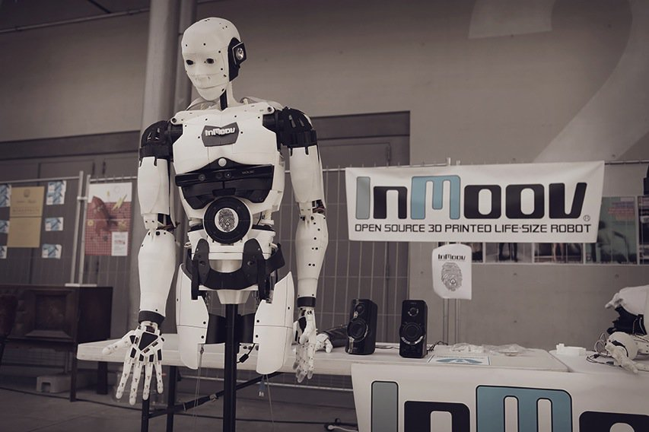
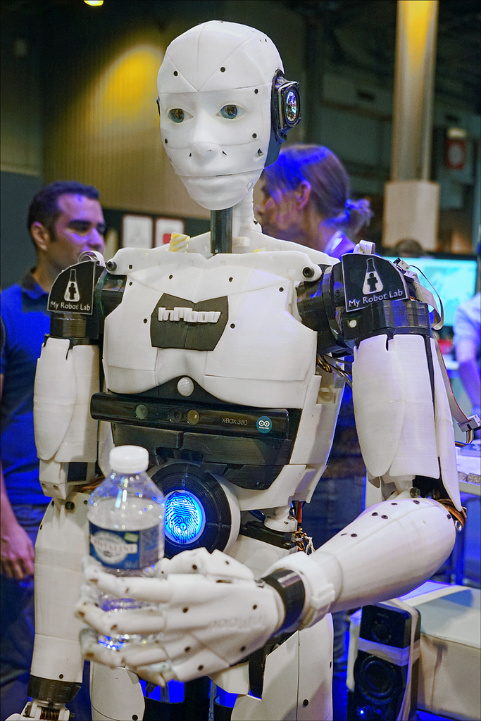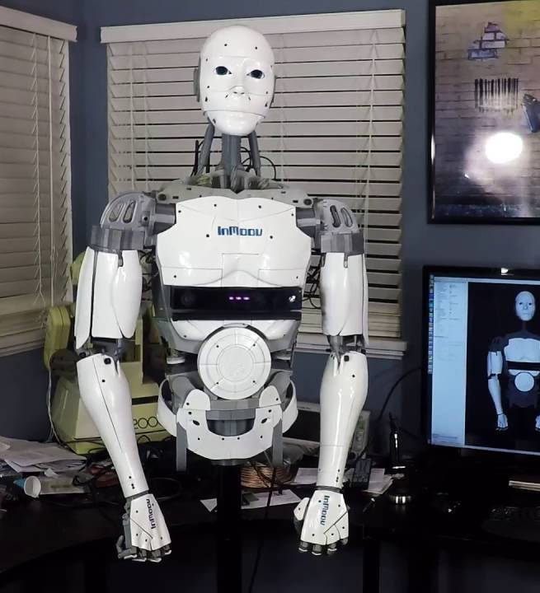
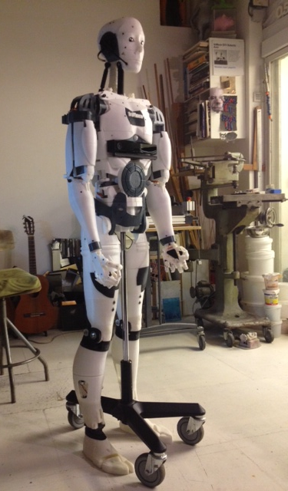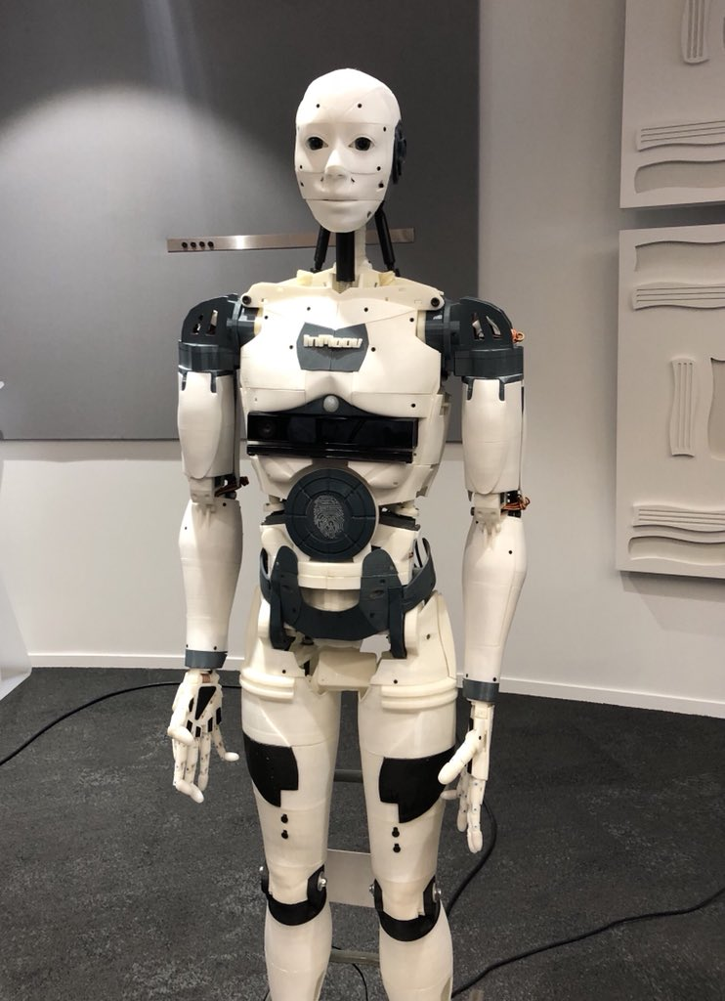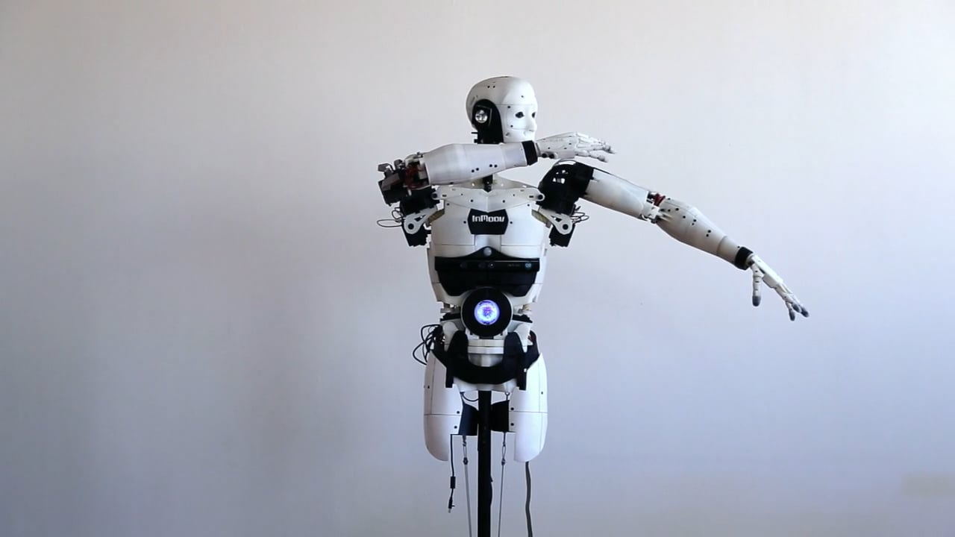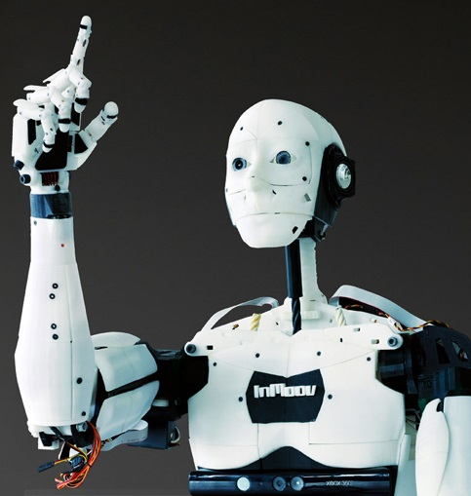

Inmoov youtube videos:
https://www.youtube.com/watch?v=2sZOyCBbows
http://inmoov.fr/youvideo/

Components Required:

Hands and forarms(Left, right):

10x servos Hobbyking
- 2x servos for the rotational wrist
- 0,8mm braided /fishing line
- Miscealenous Bolts for hardware store
- 8KG ABS/PLA

Arms and shoulders(Left, right):
- 8X Servos for arms and shoulders.
Microcontrollers and ServoBoard:

- 2X Arduino Mega

2X Adafruit 16-Channel 12-bit PWM/Servo Shield
- 1X Raspberry Pi
- 1X pi Camera

Features:
- Text to speech and speech to text conversion using espeak and raspberry pi
- Object tracking and following using raspberry pi camera.
- Using keras and tensorflow for object detection.

Work completed:
